**DBS201 Assignment 2**

**Due Friday, December 2nd in class and at the beginning of the class, Late penalty is 20% per day, Will not be accepted after the last class of the term.**

**Worth 10% of final mark**

This is a group assignment, allowable Group size: 3-4 persons. You must submit in hard copy or printed format

**Required for submission:**

***The assignment contains two parts. In the first part, you are provided 5 user views. You are required to provide 3NF solutions for each view. Clearly state the relationship between entities, identify any dependencies including multi valued/partial/transitive (if any) and show your steps to final resolved 3NF for each view. You may treat each view independently. In the second part, you are provided a narration of a store. You are required to provide ERD for the given narration in the second part.***

You must hand in the Submissions Form (below) with your assignment (one per group).

Student Assignment Submission Form

I/we declare that the attached assignment is my/our own work in accordance with the Seneca Academic Policy. No part of this assignment has been copied manually or electronically from any other source (including web sites) **or distributed to other students**

Name(s) Student ID(s) Signature

**Part I**

There are five user views from which you can determine an optimal 3NF logical solution.

Verify the relationships in between entities as you normalize. If it is a true M:N, then composite key is required. However if there is a 1:M relationship, then one of the key attributes should be placed as a non-key attribute (or foreign key) in the other relation.

(USER VIEW #1)

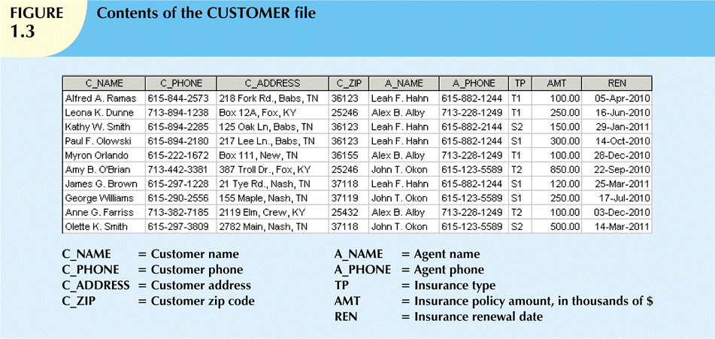

**UNF**

CUSTOMER[C_NAME,C_PHONE,C_ADD,ZIP(A_NAME,A_PHONE,TP,AMT,DATE)]

**1NF**

CUSTOMER[C_NAME,C_PHONE,C_ADD,ZIP,A_NAME,A_PHONE,TP,AMT,DATE]

**2NF**

CUSTOMER[C_NAME,C_PHONE,C_ADD,ZIP,TP,AMT,DATE,A_NAME FK]

AGENT[A_NAME,A_PHONE]

**3NF**

CUSTOMER[C_NAME,C_PHONE,C_ZIP,C_STREET,A_ID,TP_ID FK]

CITY[C_ZIP,C_CITY,C_STORE]

AGENT[A_ID,A_NAME,A_PHONE]

INSURANCE POLICY[TP_ID,TP,AMT,REN]

(USER VIEW #2)

|  |  |  |  |  |
| --- | --- | --- | --- | --- |
| ENG-A-PLUS  Employees By Project Report | | | | |
| **ProjNum** | **Project Name** | **Emp Num** | **Name** | **Years In**  **Company** |
| 06-2337 | Build North Bay Shopping Centre | 311 | Roy Hall | 7 |
|  |  | 201 | Joan Relton | 11 |
|  |  | 299 | Ann Rogers | 9 |
|  |  | 331 | Alex Wang | 5 |
| 06-2338 | Addition to South Lake Hospital | 205 | Pui-Ling Chan | 11 |
|  |  | 298 | Robert Guilmore | 9 |
|  |  | 311 | Roy Hall | 7 |
|  |  | 201 | Joan Relton | 11 |
|  |  | 331 | Alex Wang | 5 |

**UNF**

PROJECT [PROJ_NUM, PROJ_NAME,(EMP_NUM, NAME, YEARS_IN_COMP)]

**1NF**

PROJECT [PROJ_NUM, PROJ_NAME, EMP_NUM, NAME, YEARS_IN_COMP]

**2NF**

PROJECT [PROJ_NUM, PROJ_NAME]

EMPLOYEE [EMP_NUM, NAME, YEARS_IN_COMP, PROJ_NUM]

**3NF**

PROJECT [PROJ_NUM, PROJ_NAME]

EMPLOYEE [EMP_NUM, NAME, YEARS_IN_COMP, PROJ_NUM]

(USER VIEW #3)

ENG-A-PLUS

EMPLOYEE BENEFITS REPORT

|  |  |  |  |  |  |
| --- | --- | --- | --- | --- | --- |
| **Emp**  **Num** | **Emp**  **Name** | **Phone** | **Benefit**  **Num.** | **Benefit** | **Start**  **Date** |
| 205 | Stan Chan | (905) 662-3887 | SU-141 | Sun Life Medical(Group 144) | 1995-01-05 |
|  |  |  | EPP-78 | Engineer Pension Plan(Grp 78) | 1994-09-15 |
|  |  |  | MU-100 | Mutual Life – Life Insurance-I | 1994-09-15 |
| 311 | Roy Hall | (416) 487-2480 | EPP-78 | Engineer Pension Plan(Grp 78) | 1999-11-15 |
|  |  |  | MU-100 | Mutual Life – Life Insurance-I | 1999-09-07 |
| 331 | Alex Wang | (905) 457-7728 | SU-141 | Sun Life Medical(Group 144) | 2002-06-22 |

**UNF**

EMPLOYEE [EMP_NUM, EMP_NAME, PHONE, (BENEFIT_NUM, BENEFIT, START_DATE)]

**1NF**

EMPLOYEE [EMP_NUM, EMP_NAME, PHONE, BENEFIT_NUM, BENEFIT, START_DATE]

**2NF**

EMPLOYEE [EMP_NUM, EMP_NAME, PHONE]

BENEFIT [BENEFIT_NUM, BENEFIT]

EMP/BEN [EMP_NUM, BENEFIT_NUM, START_DATE]

**3NF**

EMPLOYEE [EMP_NUM, EMP_NAME, PHONE]

BENEFIT [BENEFIT_NUM, BENEFIT]

EMP/BEN [EMP_NUM, BENEFIT_NUM, START_DATE]

(USER VIEW #4)

|  |  |  |  |  |
| --- | --- | --- | --- | --- |
| ENG-A-PLUS  CUSTOMERS BY GROUP | | | | |
| **Customer**  **Type** | **Customer**  **Sub-Group** | **Customer**  **Name** | **Phone** | **FAX** |
| Government | Federal | Department of Defense | (877)223-4172 | (207)223-4179 |
|  |  | Department of Agriculture | (877)223-4111 | (207)223-4113 |
|  |  | National Archives | (877)223-4201 | (207)223-4202 |
| Gouvernment | Provincial | Ministry of Transportation | 595)326-5173 | (595)326-5181 |
|  |  | Ministry of Health | (583)566-4744 | (583)566-4743 |
| Corporation | Financial Services | DUCA Credit Union | (859)692-4292 | (589)692-4299 |
| Corporation | Financial Services | Bank of Nova Scotia | (978)288-4319 | (817)288-5319 |
| Corporation | Oil | Esso Imperial | (856)945-5168 | (856)945-5163 |
| Corporation | Retail | Sears Canada | (678)848-9987 | (678)-948-9989 |

**UNF**

CUSTOMER [CUST_TYPE, CUST_SUB, (CUST_NAME, PHONE, FAX)]

**1NF**

CUSTOMER [CUST_TYPE, CUST_SUB, CUST_NAME, PHONE, FAX]

**2NF**

CUSTOMER [CUST_TYPE, CUST_SUB]

DETAILS [CUST_NAME, PHONE, FAX, CUST_TYPE]

**3NF**

CUSTOMER_TYPE [C_TYPE_ID, C_TYPE]

CUSTOMER_SUB_TYPE [C_TYPEID, C_SUB_ID, C_SUB]

CUSTOMER DETAIL [C_ID, C_NAME, C_PHONE, C_FAX]

CUSTOMER [C_ID, C_TYPE_ID, C_SUB_ID]

(USER VIEW #5)

|  |  |  |  |  |  |  |  |  |  |  |  |
| --- | --- | --- | --- | --- | --- | --- | --- | --- | --- | --- | --- |
| ENG-A-PLUS  Weekly Sales Report | | | | | | | | | | | |
|  | | | | | | | | | | | |
| **Equip**  **Class** | **Class**  **Description** | **Equip**  **Num** | **Equipment**  **Description** | **Charge** | **Qty** | **Inv.**  **Num.** | **Inv.**  **Date** | **Sales**  **Person** | **Cust**  **No** |
| OFF | Office Copier | P100 | Kodac Photocopier | $420.00 | 2 | EAP-44720 | 05-10-17 | 23-Oliv Gardenor | 103 | |
| MIX | Concrete Mix | CMT22 | Concrete Mixer | $4000.00 | 20 | EAP-44720 | 05-10-17 | 23-Oliv Gardenor | 103 | |
| TRU | Wood Trusses | A100 | 50’ x 16’ Roofing | $1200.00 | 48 | EAP-44721 | 05-10-18 | 13-Walter Chan | 83 | |
| FRM | Framing | A137 | 2 x 4 x 8 Poplar | $7500.00 | 1000 | EAP-44721 | 05-10-18 | 13-Walter Chan | 83 | |
| OFF | Office Copier | P100 | Kodac Photocopier | $840.00 | 4 | EAP-44721 | 05-10-18 | 13-Walter Chan | 83 | |
| STF | Steel Framing | STL100 | Front Steel Loader | $1500.00 | 3 | EAP-44721 | 05-10-18 | 13-Walter Chan | 83 | |
| MIX | Crushd Stone | ST22 | Stone Crusher | $950.00 | 1 | EAP-44722 | 05-10-18 | 23-Oliv Gardenor | 46 | |
| FLD | Front Loader | FL660 | Front Loading Device | $450 | 1 | EAP-44722 | 05-10-18 | 23-Oliv Gardenor | 46 | |
| CRA | Overhead  Lift | CRA-11 | 120’ Overhead Crane | $9000 | 3 | EAP-44723 | 05-10-18 | 20-Joe Shoelly | 52 | |

**UNF**

REPORT [CUST_NUM, SALES, IN_DATE, INV_NUM, (EQUIP_CLASS, CLASS_DESC, EQUIP_NUM, EQUIP_DESC, CHARGE, QTY)]

**1NF**

REPORT [CUST_NUM, SALES, IN_DATE, INV_NUM, EQUIP_CLASS, CLASS_DESC, EQUIP_NUM, EQUIP_DESC, CHARGE, QTY]

**2NF**

CUSTOMER [CUST_NUM, SALES, IN_DATE, INV_NUM]

EQUIPMENT [EQUIP_NUM, CLASS_DESC, EQUIP_CLASS, EQUIP_DESC, CHARGE, QTY, CUST_NUM]

**3NF**

CUSTOMER [CUST_NUM, SALES]

INVOICE DETAIL [INV_NUM, EQUIP_NUM, EQUIP_CLASS, _ID, CUST_NO, INV_DATE]

EQUIPMENT [EQUIP_NUM, EQUIP_CLASS, CLASS_DESCRIPTION, AMOUNT]

CLASS [EQUIP_CLASS, CLASS_DESC]

**PART II: Produce Final Resolved ERD using Crow’s Foot Notation**

**BUSINESS NARRATIVE OF ABC Store**

The ABCstore sells general groceries. Many of the customers are regular ones who stop in to buy products, which are grouped by department. As a convenience, the store offers also a local delivery service for its registered customers. When the products are delivered to the store, employees record their full name, SKU code (Stock Keeping Unit code or Product Code), cost (>0), quantity in stock (by adding delivered number to the existing number of product units), package size and last purchase date before stocking these items.

The store has a few cash registers (departments), one of them by the deli counter, the other by dairy section and the third one by produce section. It employs several employees, depending on the time of day and how busy the store is. At each register, the cashier logs in to the register at the start of his/her shift and logs out at the end of each day. This register log is used by the owner to calculate number of hours for each cashier.

Each employee’s full name, address, home phone number and SIN are recorded. Employees are paid per hour (>0) and their pay per hour rate is also recorded. There are several types of employees (like Cashier, Delivery, Manager, Clerk). Some of the employees (called managers) supervise the other ones and decide about their shifts and hours. A manager supervises up to 5 employees.

Customers who apply for a delivery service must sign up by providing their full name, address and their home phone number. A registered customer may exist in the database even if he/she has not made any purchase.

Each sale is identified by Receipt Number, timestamp (date and time) and sale type (Register or Delivery) and further consists of the sale item number with a quantity, unit price and item cost for each product sold. A sale may contain multiple products and each sale has track record of the employee (serviced that sale) and the register information. The total sale cost is calculated by the register program.

Note: Create meaningful names for all attributes; use # symbol for PK, FK for Foreign key, * for not null attributes. Include ALL attributes for each entity incl. composite PK and every FK. You must NOT have many-to-many relationships in your Resolved ERD. You must show any cardinalities and optional/mandatory participation of the entities in the ERD.



*Are mandatory